**ENGLISH LANGUAGE WRITING TIPS**

Quite often the questions provide the opportunity to write about personal stories, so it is worth considering in advance about a time you felt happy/ sad/ guilty/ proud/ ashamed/ scared etc.

You should consider all of the techniques you know for descriptive writing as they apply to imaginative writing as well.

Try some of the following titles:

1. The Gift

2. Write about a time you felt scared

3. Write a story which begins with these words: Sam knew there was trouble coming as soon as Mrs Thomas closed the door.

4. A Night Out

5. Write a story which ends with the following: My mother just looked at me and said, “ I told you it would never work.” I realise now she was absolutely right.

6. The Disaster

7. Write about a time you felt guilty.

8. The Babysitter

9. Write a story that begins with these words: Alex held his / her breath as the footsteps faded slowly away.

10. The Surprise.

11. The Journey of a Lifetime

12. Write about a time you felt ashamed of yourself

13. The Fugitive

14. Continue the following: ‘Everyone said you should never go back but I could not resist’

15. An unforgettable moment

16. Write about an occasion when you felt let down.

17. The Stranger.

18. The Explosion.

19. Or, continue the following: Life had been good, until now … 16

20. Or, Write a story which ends: … and I felt so relieved

For imaginative writing you do not have to write from the perspective of yourself. For example, you may wish to write from the perspective of a persona or character. If the question asked you to write about a time you felt guilty, you may wish to think about a character in prison and write from their perspective. Remember the examiner will be reading lots of papers from people your age so if you can invent a character you will gain the interest of the examiner more.

**Stand out from the crowd**  
If you think of the number of students across the country that are taking the same exam as you, you will know how important it is to try and get the examiner’s attention.

A few simple ways to do this might be to plan different opening sections for the essay.

For instance include a shocking statement to draw the reader’s attention in automatically. Or introduce your character straight away so the reader feels like they are part of the action or try beginning with speech.

**S S L L S**

**Use this technique to create drama and tension through the use of short and long sentences in openings.**

**S – short sentence  
S – short sentence  
L – long sentence  
L – long sentence  
S – short sentence**

**The paragraph will therefore consist of 5 sentences – 2 short dramatic, followed by 2 longer sentences giving detail, and end with another short dramatic sentence.**

**Example:**

**Hesitantly, I knocked the door. It swung open. Before me stood what looked like a crow in human form, glowering at me with eyes as sharp as needles. I stepped back in fear, as the crow lurched towards me. My legs crumbled.**

Top tips

* Try to use a variety of punctuation ( :, ;?!) this automatically gives you more marks.
* Make sure you use a variety of sentence structures for effect. Use long descriptive sentences followed by short snappy ones.
* Try to expand your vocabulary. Use words you do not normally use. It doesn’t matter if you’re not completely sure how to spell them. You get points for trying.
* Use standard English and avoid slang
* Make sure you engage your reader. Use any trick you can to guarantee your reader is interested and continues to read.
* Choose one tense to write in and stick to it, sometimes it’s easier to choose past tense
* Constantly refer to your senses, what could you see, hear, smell, feel, taste?
* Use similes and metaphors
* Use personification and onomatopoeia
* Describe every detail. Use lots of adjectives
* Plan the time to spend 10 minutes planning, 40 minutes writing and 10 minutes checking.
* Have a clear and fairly simple plotline – avoid an epic.
* Use personal experience such as something/somebody/somewhere you know as a starting point.
* Keep the number of characters in the story to a minimum. It is better to have two well developed characters in a story, than 15 whom we only meet once!
* Make paragraphs clear – use clear linking connectives and/or clear indents.
* The structure of the story in linked to the paragraphs – keep it clear and simple. You may want to ‘play’ with the structure, however e.g. start the story at the end and work in flashback or begin the story in the middle of the plot – if confident!
* Have a clear ending – if a cliff-hanger do it well, rather than just… finish…
* Avoid haunted houses, teenage parties, rap lyrics, lost in the woods, starting with first person ‘I’ and switching halfway through to third person ‘He/She’, doing the same for present and past tense… UNLESS you know you can handle the above skilfully.
* Vary sentence types – use simple, compound and complex sentences.
* Vary the punctuation beyond full stops and commas.
* Do not repeat the same vocabulary over and over and over… Quality is more important than quantity BUT the piece should be a decent length. Depending upon handwriting size, aim for up to 2 sides of A4 in the booklet.
* Rule of three

**You need a mixture of simple, compound and complex sentences to make interesting reading:**

**SIMPLE**

*The receptionist leant across the desk.*

Useful for effect if very short!

*The child cried.*

**COMPOUND**

Don’t forget the comma before the connective

*The receptionist leant across the desk, and fixed me with a glassy stare.*

These are two simple sentences joined together with connectives like: *for and nor but or yet so*

**COMPLEX**

********** Interesting when they are turned around and connectives are **put first** **********

Don’t forget the comma between the clauses.

*Although she wanted to go, she knew she had to stay.*

*Because he helps them score winning goals, some players regard the coach as a superhero.*

Could be written as

*Some players regard the coach as a superhero, because he helps them score winning goals.*

*I need to go to the doctor, because I have a headache.*

Clauses are joined with connectives like: *after although as as if as long as as much as as soon as as though because before even even if even though if if only in as much in order that just as now once provded provided that rather than since so that supposing than that though unless until when whenever where whereas wherever whether which while who whoever why*

**MIXING THEM UP LIKE THIS** (in this example complex then compound then simple)

*Although matches are always frightening, the team felt confident for the Cup Final. They had been training whenever possible with their new coach, and had more rehearsed moves than they had last season. They were ready!*

**Sentence variety is really important – most sentences start with’ the’, or ‘I’ or ‘he’ or ‘she’ - do not do this but make yours stand out:**

**Start with two adjectives**

*Frozen and scared, he crouched in the darkness like a beaten animal.*

**Start or end with ‘ing’ word**

*Straining with the effort, the man pulled the drowning dog from the river.*

*Hoping that no-one noticed, the student creeped in late to the back of the class.*

These clauses can be the other way around like this:

*He trudged along the ski slope, wishing he had brought his skis.*

*The teacher gave the student advice, hoping his words would not fall on deaf ears.*

**Begin with ‘ly’ word** (adverb)

*Carefully, I cut the words I needed from the newspaper and burned the rest.*

*Slowly blowing out the candles, he didn’t have the heart to tell them it wasn’t his birthday.*

**Weak interruptions**

Adding a piece of additional information into a sentence, surrounded by commas:

*My old neighbour, who loves reading, is visiting the library.*

*Christmas, my favourite time of the year, is just a few weeks away.*

**Use one or two semicolons to impress.**

They can be used to link 2 sentences that are about same topic:

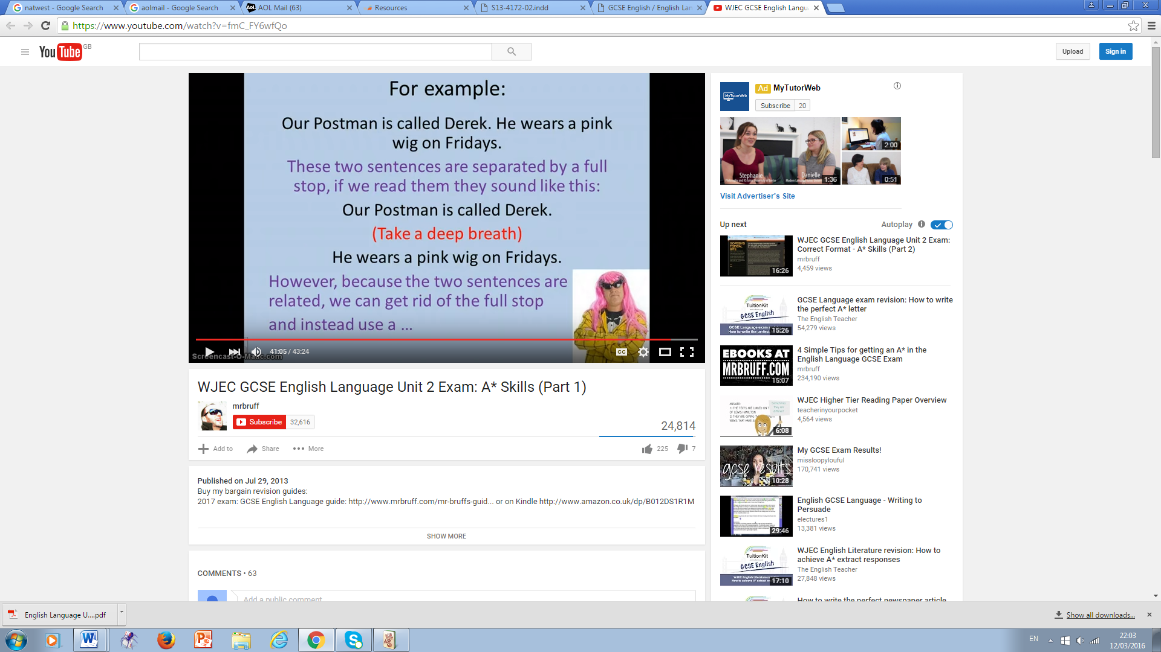

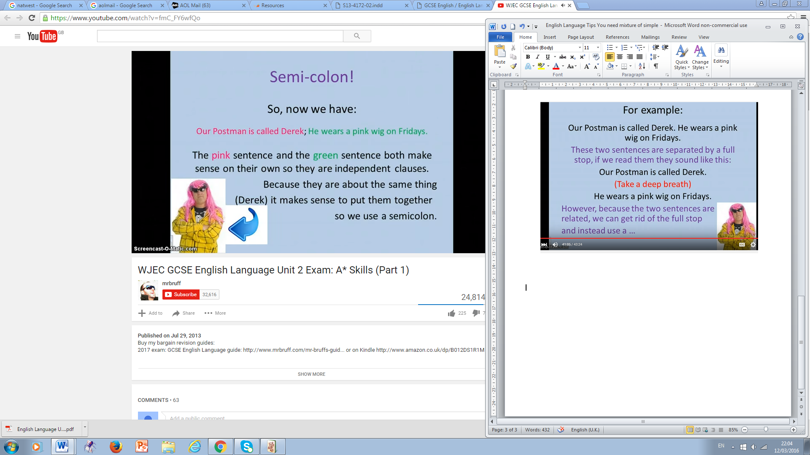

They have to be complete sentences either side of the semi-colon:

*I love Derek’s pink wig, but I don’t want to wear it.*

We use a comma here because the sentences do not make sense on their own.

**WRITING EXAMPLE SHOWING TIPS AND PHRASES**

Oh bliss, as I snuggled deeper into my duvet cocoon. Today was going to be a good day. My curtains were struggling to hold back the sun, as I lazily glanced over at my bright green, illuminated, digital (and state of the art) bedside clock. The numbers 8, 0 and 5 scorched themselves through my eyeballs and embedded themselves into the back of my skull, as I landed with a thud onto the hard floor. ‘Stupid alarm!’ Short, short, long, long, short.

Trying to free my duvet-entangled ankles, I launched myself backwards and head first into the doorframe. ‘Aaghhnngg stupid, stupid duvet’, I screamed in pain, as I lay sprawled once again on the floor like a starfish. No time for a shower. Diving into the bathroom, I grabbed frantically for the toothbrush, deodorant and any other toiletries within arm’s reach. Five frenzied minutes later I was ready to pull on my new interview clothes, which thankfully I had laid out the night before, along with my new shiny black shoes.

‘Bus? Train? Bus? Train?’ I grilled myself as I leapt down the last three stairs, grabbed my bag and hurled my pin-striped body through the front door (rule of three). ‘Train, train, train’, I repeated uselessly to myself as I legged it in the direction of the train station two streets away. People were staring. I had planned this day for two weeks, after I had been short-listed for the position of assistant manager in the new four star hotel in town**;** now it seemed to be all going horribly wrong. At the train station I checked the boards and my watch, and headed for platform one**;** I had two minutes and thankfully there were no delays showing. I started to calm down just as a train sped through at full speed without stopping. The bad news? - that was my train.

I had been shocked when the letter came through inviting me for an interview. My application had apparently made ‘an exceptional impression’ and they would be ‘delighted’ to meet me today at 10am. I had bought a new suit, new shoes and a new briefcase -which I probably could not afford - determined to make the right first impression. I had researched and rehearsed every possible interview question known to man. I was as prepared as anyone could be. I was confident and capable. I was late.

Twenty minutes later I was finally sat on a train, which was so sluggish I felt like I was being taken on a leisurely safari park ride showing off London’s office blocks and graffiti walls. The air inside the train was like a sauna and I could feel my shirt sticking to my back. Hopelessness crept through my body and settled as a tremor on my lips, and the mind which had been full of dreams and hopes only last night was now flooded with despair. Powerless and beaten (two adjectives), I closed my eyes and prayed for this waking nightmare to end.

Eventually, I managed to free myself from the uncooperative train, and elbowing commuters out of the way, forced myself through the ticket barrier. As the church bells struck ten times on the hour, I flew down the three short streets leading to the two huge and shiny revolving glass doors. Wearing my best smile and heart pounding in my throat, I leaned across the reception desk at 10.01, and came eyeball to eyeball with the glassy stare of my arch nemesis from year7….. and that wiped the smile off my face.

Or and my tongue stumbled and a tangle of meaningless words came out.

Pick out ‘ly’ words and ‘ing’ words to start sentences and the rule of three and starting with two adjectives

‘into my duvet cocoon’ is a metaphor and the bit about the numbers embedding themselves in his skull

‘like a starfish’ is a simile and bit about safari park ride

It is interesting, structured with paragraphs, and contains a lot of good punctuation and varied sentence lengths.

It would cover a time when you were nervous or frustrated and the ending is a good clause to end with.

E.g. write a story which ends ….. ‘and that wiped the smile off my face’.

If it had to say …..’ and that wiped the smile off his or her face’, then substitute first for third person

i.e.

Oh bliss as he (she) snuggled deeper into his (her) cocoon or give them a name

i.e.

Oh bliss as Ben snuggled deeper into his cocoon.

You could change ending to cover a different scenario

E.g. to end with ….. ‘and I felt so relieved’

I leaned across the reception desk at 10.01 and came face to cheery face with my best mate from year 7. His smile had always been infectious and we both started to laugh.

**WRITING EXAMPLE SHOWING TIPS AND PHRASES**

Life had been good until now. Domestic chaos had been averted. This was all about to change though, as before me an ugly hostage situation was developing. The hostage-taker had decided to expire in mid-cycle in a most spectacular way, holding my favourite jeans and hoodie captive in lifeless, smelly water. My washing machine had broken down.

Thinking about it, my robotic slave may have carefully planned its own demise as a master counterstroke. Perhaps he had felt undervalued, unappreciated and taken for granted (rule of 3), and perhaps I had contributed to these negative feelings. When was the last time I had defluffed? Perhaps that duvet and sleeping bag I had managed to stuff in last week was asking too much? When did I last rinse the powder drawer?

This was a big deal: I read once humans can last 3 days without water, but without washing machines …..much much less. I don’t think I ever cleaned the filter.

Remembering the very first load of washing we sat and watched for an hour and a half fills me with nostalgia. We had fought over who was to press the ‘on’ button, and then sat back mesmerised at the miracle, until it ‘clicked’ to show its work was done. There had been a blazing blue sky marbled with pearl white as I proudly pegged out my washing to dry. I had stood in the soundless breeze surrounded by the clean smell of lavender, feeling like the lady in the ‘Comfort’ advert. When I closed my eyes I was running through meadows filled with butterflies. He had risen to the challenge on every occasion. He had never let us down ….. never that is until now.

I look like something you would find in a spaceship: in today’s world yesterday’s methods just don’t work. I am eco-friendly, colours friendly and wool friendly. I am an anchor, a crutch and a true trooper (2 rules of 3). Reassuringly, my little glass window exposes my no nonsense, no frills approach to getting things done (you trust me more when you can see what I am doing). My colourful swirling of the washing is like a kaleidoscope, designed to be viewed and admired; even if it is only by the cat! The naked fact is I am essential.

I saw your first puzzled stare. I saw the fear creep across your face and settle as a faint tremor on your lips. I saw your eyes dance in panic. I felt you shake me and I heard the tangle of ugly words, your voice filled with temper. I saw your beauty vanish. Eventually, I heard your pleas. You are all totally dependent on my magic, but I was dumped in the utility room, ignored and used. If you value your free time then you really should have valued me more. The silence is becoming uncomfortable and you’ve certaintly noticed me now haven’t you?

Thinking – start with ‘ing’ word

Remembering – also an ‘ing’ word

Reassuringly – ‘ly’ word

Rule of 3

Look short, short, long, long and short first paragraph

Loads of different punctuation

Loads of different sentence lengths

Loads of interesting vocabulary

Same tense all way through

Simile (kaleidoscope)

Metaphor (calling machine a ‘hostage-taker’ and ‘robotic slave’)

Lots of personification as if washing machine is alive

Onomatopoeia (clicked)

Detailed and lots of adjectives

**Structure linked to paragraphs**

**YOU CAN ADAPT THIS STORY**

Look at these titles for this story -

1. Continue the following: Life had been good, until now …..

This is starting sentence already

2. Write about an occasion when you felt let down

Included in this story is –

‘He had never let us down ….. never that is until now’

3. Write about a time you felt guilty

The second paragraph could just end with

‘Should I feel guilty? ….. because I do’.