**Firstly ①DEALING WITH PAIN**

* **The lack of effective anaesthetics** before 1800’s held back development of surgery because people were fully conscious and could feel everything
* Difficult to operate on a patient **writhing in pain**!! – surgeons had to be quick and assistants had to hold patients down
* Operations had to be quick, simple and not go too deep (speed is emphasised in many source materials but speed also caused accidents along with the fact that patients were not lying still)
* Surgery was seen as a last resort
* Most common operation was amputation – cutting off a limb
* Patients could die of shock because of pain involved
* Before discovery of chloroform in 1847, nitrous oxide (laughing gas) was identified as a potential anaesthetic by Humphrey Davey in 1799, but was not taken seriously as it did not knock people out
* In 1846 the first public demonstration of ether as an anaesthetic was carried out by William Morton, but it is irritant and caused coughing and vomiting (vomiting could kill an unconscious patient) and was also explosive so risky to use at a time of candle and gas lamps
* Also in 1846 Robert Liston amputated a leg with ether
* Milestone was when **JAMES SIMPSON** discovered **CHLOROFORM in 1847** – the first **effective** anaesthetic – first man to receive a knighthood for contribution to medicine
* Chloroform used widely in operating theatres and to reduce pain of childbirth – but sometimes affected heart and patients could die suddenly
* It became popular when Queen Victoria used it in child birth
* John Snow’s inhaler regulated the dose, which helped prevent heart problems because dose could be controlled better
* It was not without its risks – first death was Hannah Greener in 1848 - scared surgeons
* Also the new anaesthetic encouraged deeper operations (surgeons could take more time because patient was not in pain thrashing about) but without solving problems of **infection** and **blood loss - this was not a good thing**
* **In fact in the 1870’s the DEATH RATE from surgery reached a high**
* **The period between 1846 – 1870 sometimes called the ‘Black Period’ of surgery**
* **Some doctors thought an unconscious patient was more likely to die than one who was awake and screaming blue murder**

**Simpsons discovery of Chloroform - one of the best medical stories of all time**

He invited other doctors around to spend an evening inhaling various chemicals to see what would happen. At one point Mrs Simpson thought it had gone quiet and walked in to find them unconscious – they had inhaled chloroform.

*Think of your mental timeline so that you do not stray outside dates stated in questions – ether 1846, then chloroform in 1847 and the period of 1846 -1870 known as Black Period of surgery

*Remember anaesthetics protect people from pain

**Why some people opposed anaesthetics**

* Some Christians thought that pain, especially the pain of childbirth, was part of God’s plan for human beings and that it was a blessing. Queen Victoria’s approval when she used it during childbirth meant people were more willing to accept chloroform
* Surgical knowledge of anaesthetics took time to spread and be adopted, as some surgeons were reluctant to change their old methods (this is quite common with medical developments)
* In 1848 Hannah Greener died while being given chloroform during an operation to remove an infected toenail – this first death scared doctors
* Anaesthetics encouraged deeper and more complex surgery, but since the problems of INFECTION and BLOOD LOSS had not been solved this was not necessarily a good thing = Black Period of surgery was 1846 – 1870 as the death rate from surgery reached new highs
* Some doctors thought an unconscious patient was more likely to die than one who was awake and screaming blue murder

Question example

Letters published in The Lancet 1849 and 1853 (important medical journal where doctors published details of their work)

1. ‘The infliction (of pain) has been invented by The Almighty God. Pain may even be considered a blessing of The Gospel, and being blessed admits to being made either well or ill’
2. ‘It is most unnatural practice. The pain and sorrow of labour exert a most powerful and useful influence upon the religious and moral character of women and upon all their future relations in life’

What was the purpose of this representation? Use the source and your own knowledge to answer the question

Answer example

The PURPOSE of these sources is to discourage people from using chloroform, as they were published shortly after James Simpson began using chloroform in operations. They both show a negative view of it, with the MESSAGE that it is part of God’s design to suffer from pain, and that chloroform goes against this and is acting against the Christian religion, including the use of chloroform during child birth.

It seems unusual for a medical journal to publish objections on religious grounds, but this was probably to have a greater effect on discouraging people. Many in the medical profession were suspicious of chloroform because it was new and Hannah Greener had died in 1848 whilst having routine surgery on her toenail. They thought opposing on religious grounds would be easier for ordinary people to understand.

Question example

Queen Victoria’s remark after being given chloroform during the birth of her eighth child was *‘Dr Snow gave that blessed chloroform and the effect was soothing, quieting and delightful beyond measure’*

What was the purpose of this representation? Use the source and your own knowledge to answer the question

These questions asking for the purpose of the representation are all about MESSAGE AND PURPOSE

* Who wrote it or painted it or drew it and why – who is it aimed at?
* What is the single biggest point that sums up their message?
* What factors may have prompted it or influenced it?

Answer example

The PURPOSE of this source is to encourage people to use chloroform as an anaesthetic. Queen Victoria was an influential person and the fact that she liked chloroform during child birth would set an example (give a positive MESSAGE) for other women who might have worried using it.

At this time there were many objections to chloroform from doctors. Some were concerned about getting the dose right, especially after the death of Hannah Greener. Others objected on religious grounds, claiming pain was a blessing from God, especially that of child birth.

Supporters of chloroform would have welcomed this message from Queen Victoria and used it to increase support.

**Then ②DEALING WITH INFECTION**

* Following development of anaesthetics, deaths from surgery **increased**
* Surgeons were doing more complex operations but had not solved the problem of infection – patients would survive the operation but die a few days later from gangrene or sepsis (blood poisoning)
* By the 1870’s the death rate from surgery reached a high
* In the 1890’s surgeons still had very little understanding of how germs spread and what caused **gangrene and sepsis**
* Gangrene is infection of dead tissue that causes foul smelling gas
* Sepsis is blood poisoning which overwhelms body with infection and causes death
* Even after **THE GERM THEORY IN 1861** it took years for doctors to apply it to surgery
* Surgeons operated without always even washing hands, wearing blood splattered clothing (status symbol!!), and the instruments used, operating table and room would not have been cleaned
* A doctor called Ignaz Semmelweis had used chloride of lime solution as a hand wash to control infection of childbirth, but it was unpleasant and had not caught on
* **JOSEPH LISTER discovered that CARBOLIC ACID reduced infection around 1867 after reading about Pasteur’s Germ Theory**
* He championed **ANTISEPTIC** conditions in surgery (i.e. when chemicals are used to destroy bacteria and prevent infection) – washing his hands and equipment in carbolic acid and spraying air around the patient during operation – death rate fell dramatically in his wards
* As usual in Medicine new ideas are always slow to catch on but by **1890’S ANTISEPTIC SURGERY WAS COMMON.**
* His ideas took a long time to catch on as is usual with new medical developments. Some surgeons did not follow his methods exactly and had different results and said he was wrong. He did not help himself in this matter because he kept changing his methods which made him look unsure of them
* Antiseptic surgery eventually developed into **aseptic surgery** where germs were removed from the operating theatre rather than the wound

**Why were surgeons resistant to Lister’s new methods?**

* Many surgeons were resistant to the use of Lister’s carbolic spray because they found it difficult to accept that they had a role in preventing infection.

Most surgeons operated in the same clothes they wore outside, and some even took pride in their blood stained aprons. When Lister suggested a link between dirty clothing and unwashed hands in the operating room, many doctors found this hard to accept.

* Many surgeons did not like the smell of carbolic spray. It dried out the hands and caused skin to crack, and it made operations longer and more expensive because additional preparation and materials were needed. Since speed was still important because the problem of blood loss had not yet been solved, it seemed a mistake to slow down the operation even further.
* Even though Lister developed his spray after the Germ Theory. Many people still did not accept that the air was full of microscopic germs. The method could therefore not be fully accepted until people fully accepted the Germ Theory.

*Think of your mental timeline and add to it now so that you do not stray outside dates stated in questions - ether 1846, then chloroform in 1847 and the period of 1846 -1870 known as Black Period of surgery – then enter Lister and his carbolic spray around 1867 after reading Pasteur’s Germ Theory in 1861 (took 6 years to apply it to surgery) – then death rates improved dramatically

*Remember antiseptics developed after anaesthetics – do not confuse these two similar words!

*Also remember that surgeons did not like carbolic spray and some did not carry out this ANTISEPTIC SURGERY properly and did not have same results and said Lister was wrong.

**Why was the problem of infection so great in the 1860’s?**

Germ Theory was when?

Get your timeline right

This period of surgery was called the ‘Black Period’ because the death rate was so high.

The problem of infection was so great because so many operations were being carried out which were becoming more complex and deeper into the body (after the introduction of effective anaesthetics to control pain) without addressing the cause and spread of infection. Anaesthetics encouraged surgery which might not have been operated on before, but the problems of infection and blood loss resulted in very high death rates.

The surgeon regularly operated in clothes he had worn outside and some even took pride in blood splattered aprons. The Germ Theory took years to take hold in surgery as surgeons did not believe the air was full of microscopic germs.

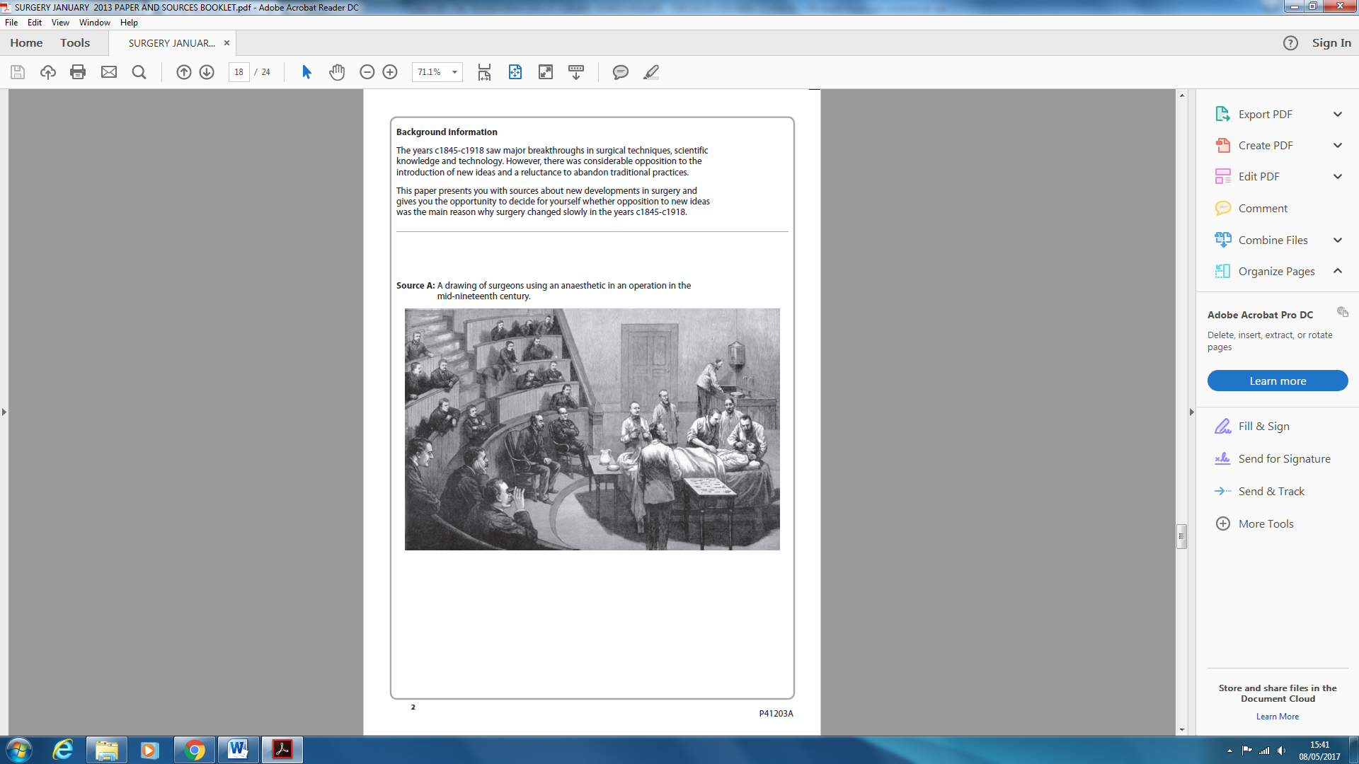January 2013 paper – sources booklet

(Note - This is an artist’s impression and looks a bit clean for an operation in progress! Remember with drawings and paintings they may not be a true snapshot of time but a representation of what happened. They may be affected by public opinion and views of the time.

It shows use of new methods - of anaesthetic and inhaler. It shows washing facilities at back of room which is improvement in hygiene along with surgeons and assistants in aprons. It looks calm and carefully planned with large team to help. Still shows unhygienic conditions of spectators watching all dressed in ordinary clothes.)

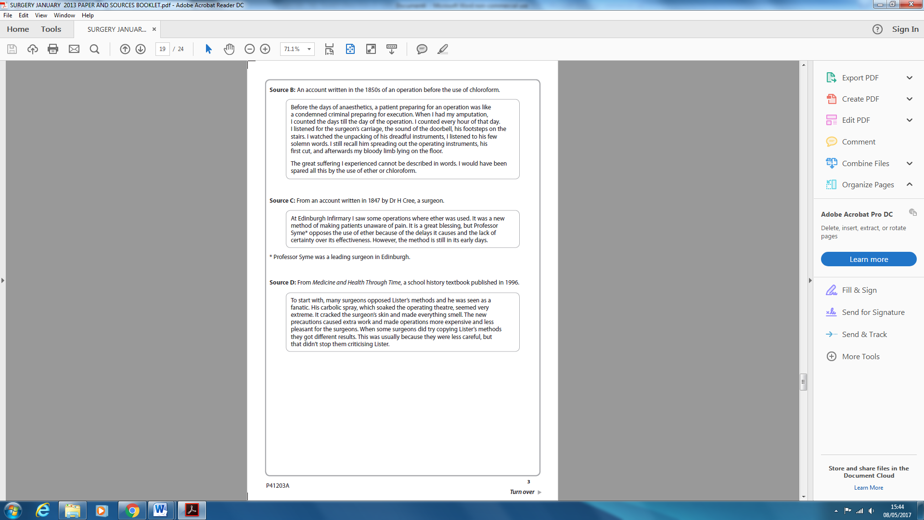(Note – Source B really builds up tension like a condemned convict and would have been spared all this with an anaesthetic. Source C shows ether is not without problems and D also shows problems with new methods.)

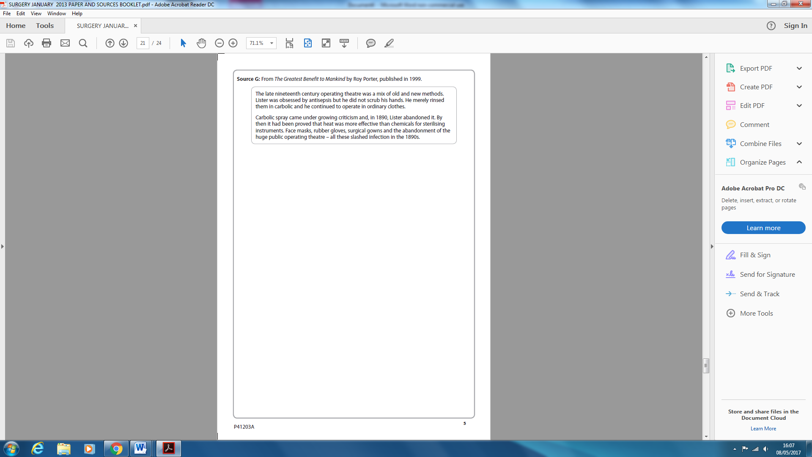

(Note – Source G is an interesting source showing a mix of old and new methods by the late 1800’s. It mentions steam sterilising (heat) and shows there had been a lot of changes by the late 1890’s)

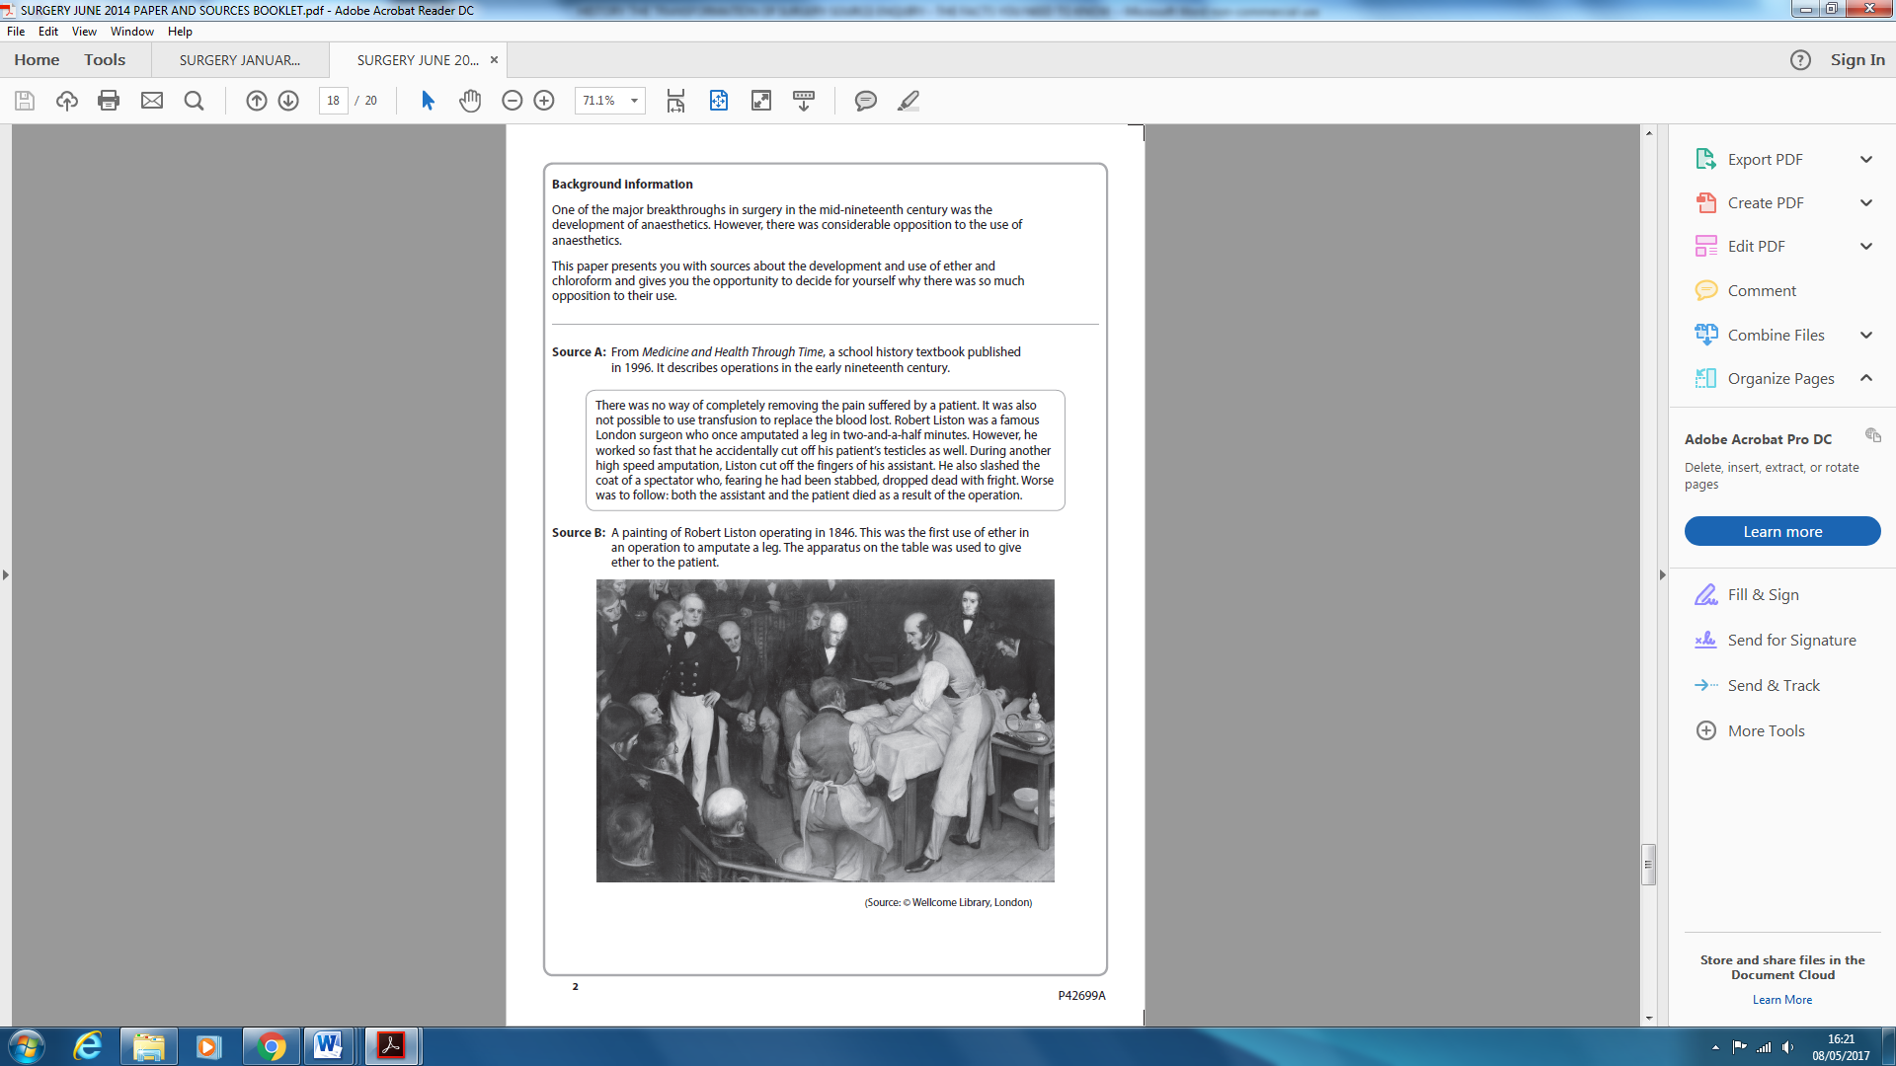Let us look in more depth at actual questions from 2014 paper on this topic

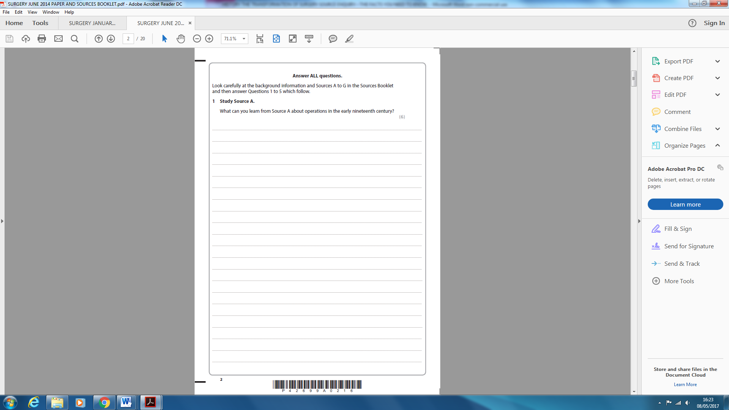

(Note – this question is worth only 6 marks and you must not give unnecessary facts – it is comprehension – what do you understand from reading it? Use details to support this – it is not asking for reams and reams of facts from your own knowledge. Two inferences can gain full marks as long as they are backed up well using facts and quotes but if you can see more, then say it.)

1. Amputations were carried out without an anaesthetic as the source says there was no way of completely removing the pain.
2. Because they were so painful, they were carried out as quickly as possible as the source says they were completed in ‘*two* and a half minutes’.
3. Blood loss was also a problem which needed speed as the source says it could not be replaced.
4. The speed of surgeons could lead to them making mistakes as the source describes quite serious ones.

(do not call surgeons ‘careless’ as they had to go at high speed in the interests of the patient – to reduce pain and blood loss)

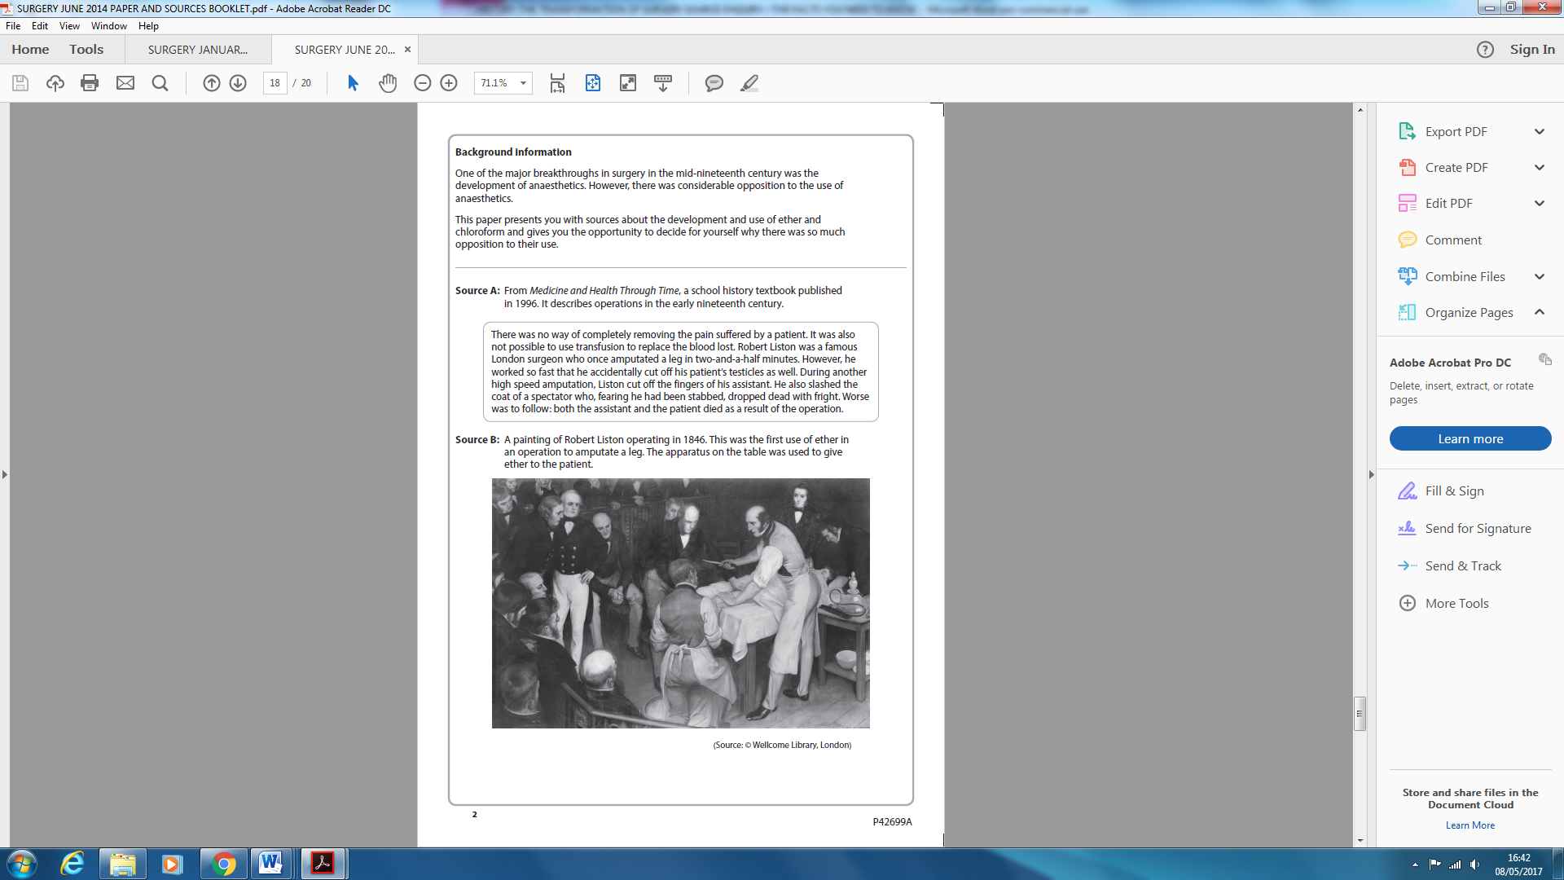

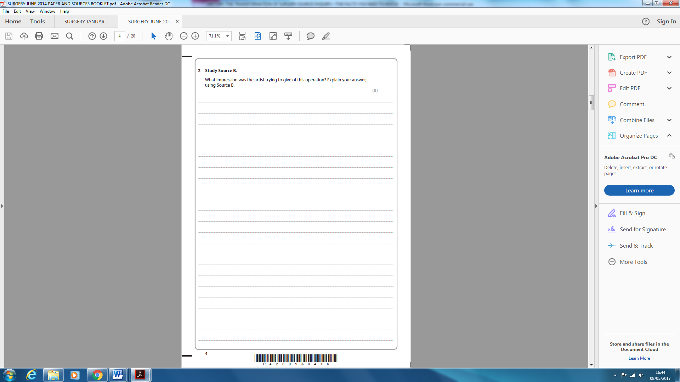(Note – this question is worth more marks and expects some of your own knowledge of the topic. These questions that ask ‘what impression is artist giving’ or ‘what is the purpose of this representation’ are looking for the MESSAGE and the PURPOSE of that message. You do not need to be an art critic and you must always be aware of your timeline so you do not mention perhaps things that have not happened yet – this is before the Germ Theory of 1861 so no point mentioning hygiene and infection)

1. The PURPOSE of this painting is to show the importance of Liston and anaesthetics.
2. This MESSAGE is conveyed by –

The facial expressions of the crowd show the importance of the event.

The crowd are dressed smartly making the event seem special.

The crowd are concentrating on what he is doing.

The artist has used light to show the importance of Liston and the bottle of ether as they are both light in a mainly dark painting - dramatic

At this time operations attracted a lot of attention, perhaps by other surgeons learning the technique and sometimes there was a showman element to them.

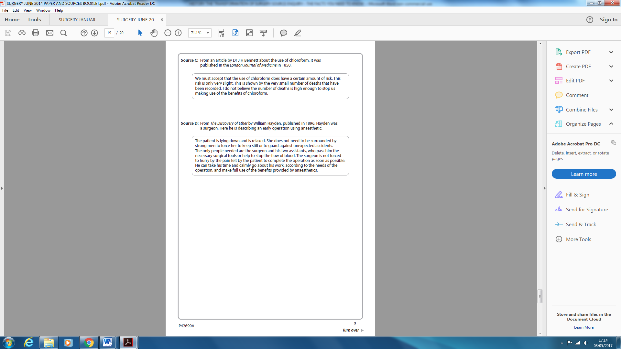

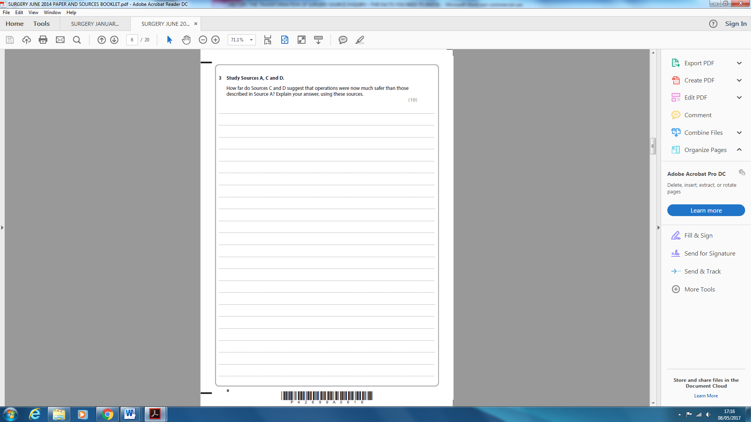

*Let us introduce ourselves to an important question type of question – the **hypothesis** question – remember a hypothesis is an idea or explanation which is based on knowledge of facts (sort of educated guess) which is not perhaps fully proven but definitely leads to a discussion – it is usually in the form of a statement.

An example of a hypothesis question is ‘How far do **sources** C and D suggest that operations were now much safer than those described in source A? Explain your answer, using these sources.

*The hypothesis is ‘operations were now much safer than those described in A’

*It is very important that you distinguish between the two different types of hypothesis question – the first asks how far do the **sources** agree with the hypothesis and the second is how far do **you** agree with the hypothesis.

*In this example the question asks how far do the sources agree with the hypothesis and **not** how far you agree with the hypothesis.

Think of a balance

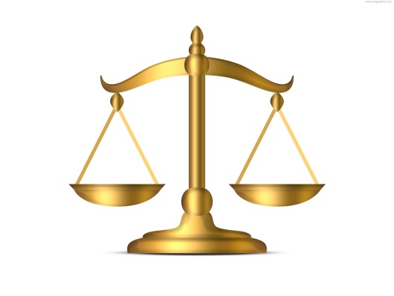

Challenging sources which disagree with hypothesis

Supporting sources which agree with hypothesis

*First read sources and compare them with the hypothesis – this is not how far you agree remember but how far the sources agree with the hypothesis. What do you think? Do they totally agree/totally disagree, or do they perhaps do a bit of both? It happens quits a lot that they contain elements of both. Usually though even if they are fairly balanced, they will be weighted more one way. It would be a good idea to annotate or underline important parts because you need evidence from the sources in your answer. Embedded quotes are useful.

Annotations for source A might include that pain and blood loss meant that speed was of the essence. It also shows the **dangers** as tells of death of three people in one operation. This source is **supportive** of hypothesis.

Annotations for source D might include how anaesthetic use had overcome problem of pain. Operations were **calmer** and surgeon could concentrate on the needs of the operation. It mentions no more ‘unexpected accidents’ and is overall positive towards anaesthetic use and is **supportive** of hypothesis.

Annotations for source C might include that it is more balanced than D as it shows both advantages of using anaesthetics and the risks associated including deaths, but concludes that on balance the **benefits outweigh the risks** and is overall **supportive** of the hypothesis.

*An important mistake that examiners constantly comment on is that students fail to cross reference sources against each other as they proceed through their answer. They do not like seeing an essay format where source A is compared to hypothesis first, then source C and then source D and so on. They want to see the sources compared to each other – they see this as a major mistake.

*So far then we have read sources and underlined important evidence and annotated our thoughts, which will be used to cross reference the sources and contribute towards the bulk of our answer – the middle bit of the essay.

The introduction will be a short paragraph which identifies **key issues** and **key argument** with a little evidence.

1. **Introduction in answer**

‘Source A identifies pain as a major problem during operations meaning speed was of the essence and shows the dangers of these quick operations which involved the death of three people from one operation, whereas C and D both show pain was no longer a major problem and C mentions the ‘very small number of deaths’ that were being recorded.’

Now let us use our source annotations to form the next paragraph as we cross reference them.

1. **Cross-referencing in answer**

‘Source D shows that the problem of pain had been overcome and operations were calmer affairs than those of source A, as they could be carried out more slowly than those in source A (where pain was of the essence). Source D mentions no more ‘unexpected accidents’, compared to the three deaths in one operation of source A, therefore supporting the hypothesis that operations had become safer. Source D is very positive towards the use of anaesthetics. Although source C also shows the advantages of using anaesthetics like source D, it is more balanced than source D as it also mentions the risks associated with them including deaths but concludes that on balance the benefits outweigh the risks and therefore also supports the hypothesis that operations had become safer.’

*Now we must cover something new – the issue of reliability of sources. How reliable are these sources as accurate sources of information? It is important isn’t it as we need to know we are basing our conclusions on accurate information?

**Evaluation of sources for reliability using NOP (Nature, Origin and Purpose)**

1. **Nature**

This is easy part

**Is it a speech, photo, painting, cartoon, diary extract, an article in a scientific journal, extract from a textbook etc.?**

1. **Origin**

This is most detailed part

**Who** produced it and are their views worth knowing – are they an expert?

**Who** is it aimed at?

**When** was it produced? Is it primary or secondary?

* Primary is produced at the time and/or by someone who was there – often a personal view of someone wrapped up in the moment – a snapshot who may not see the bigger picture
* Secondary is a source after the event or by someone who was not there – again often a personal view

**Opinionated or biased or balanced/factual/informative**

**Modest or exaggerating?**

**Limited view or broad view?**

**A note about primary sources**

The thing about paintings, drawings and cartoons is that they capture the spirit of the time and the feelings of people at that time

The thing about photos is that they capture moments in history in vivid detail but can be posed and are controlled by photographer – we do not see outside of the photograph do we?

What about newspapers? They can provide a record of events but they may be biased and contain propaganda.

What about interviews? They can take place years later for biographies with faded memory and with benefit of hindsight the interviewee may alter the past.

**A note about secondary sources**

Can be clearer because hindsight puts things into context.

Often a narrower view concentrating on a particular enquiry and well referenced e.g. textbook

1. **Purpose**

For example: adverts are designed to make you buy the idea or product, speeches are usually to support the topic, was it propaganda? , was it designed for public or private knowledge? , textbooks are usually to educate and are well referenced.

Compare all of above NOP with your own knowledge and do they match up?

1. **Reliability in answer**

‘There is no problem with reliability from any of these sources as A is from a historian who would have done a lot of research on primary sources and would also have the value of hindsight and be able to see the bigger picture of events and put things in context. Sources C and D are both written in the period, one from a leading scientific journal and one from a textbook on ether which is designed to educate and would be regarded as reliable.’

1. **Own knowledge in answer**

‘My own knowledge of the time is that ether and chloroform were important because they enabled operations to be carried out without patients feeling pain and surgeons could take their time. These longer operations however encouraged surgeons to carry out deeper and more complex procedures which resulted in the ‘Black Period' of surgery during this time where death rates were at their highest, but this is not the impression given in sources C and D.’

Now address the question.

1. **Summary in answer**

‘The weight of evidence from C and D is that operations had become much safer than those described in source A after anaesthetics. Even though there were still some deaths, they were not as a result of speed and the benefits still outweighed the risks of not operating.

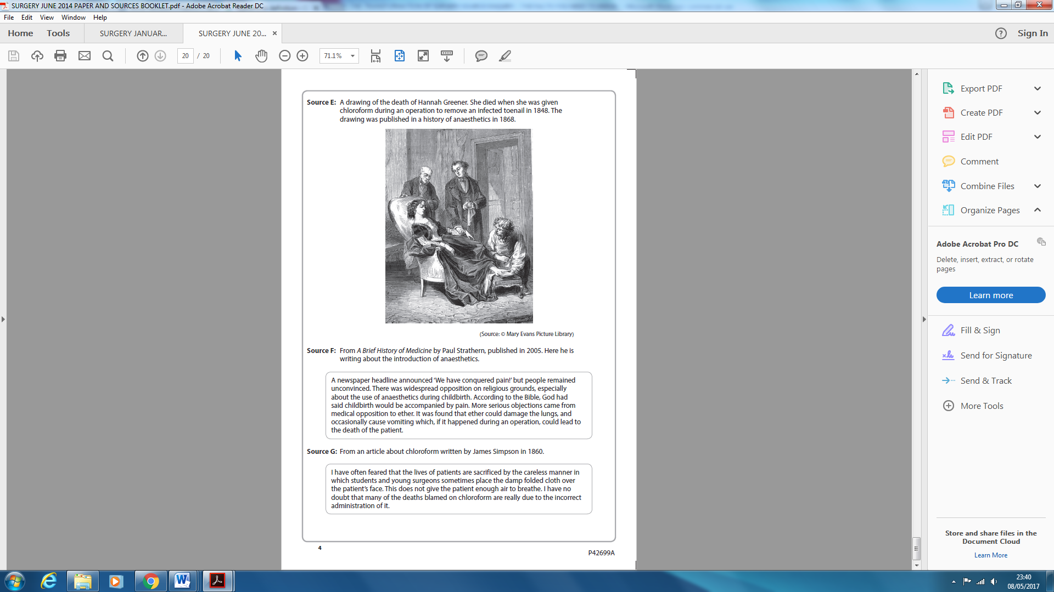

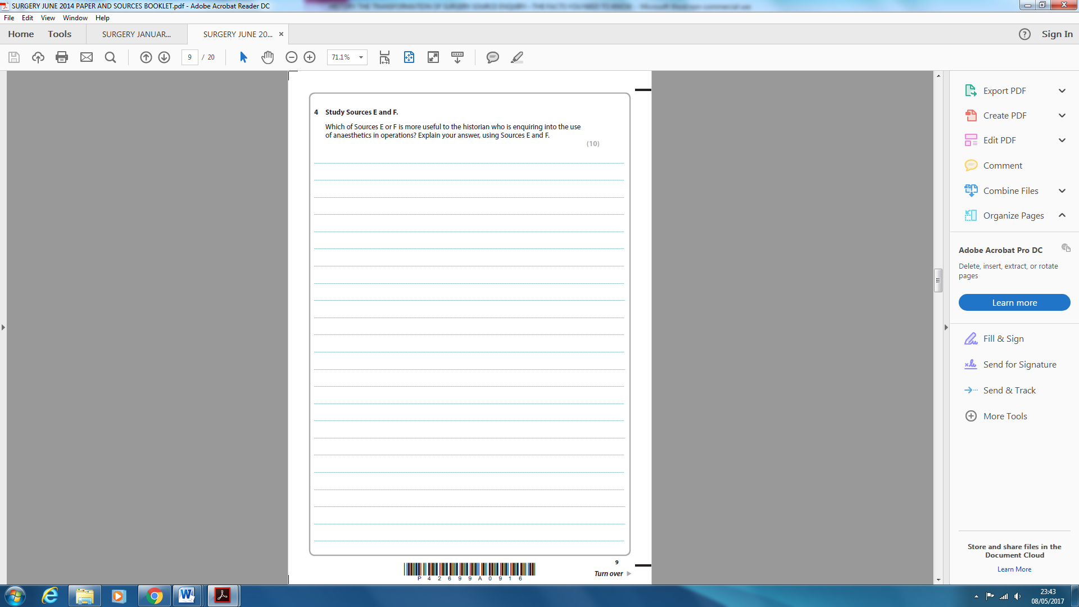

*Let us introduce ourselves to another important type of question – the **usefulness** question. Remember a source can never be useful or useless in their own right – it all depends what they are being used for, so read the whole question: useful for what? A propaganda source about the First World War might be useless for telling what actually happened, but very useful for telling you how the government tried to persuade people to support the war effort. Again cartoons are highly unreliable but useful because they can show attitudes at the time.

USEFULNESS QUESTION

* NOP and reliability of all sources
* Content – what are sources saying and are they on topic for enquiry?
* Value? – what are they good at doing? – valuable for certain things but not others?
* Which is more useful and why for this particular enquiry and does it have limitations?
* Add your own knowledge and do they fit with it?

1. **NOP and reliability in answer**

‘Source E is a drawing published in a history textbook on anaesthetics whose purpose is to educate. The reliability maybe good as it was drawn around the time chloroform was being used for surgery, but the artist may not be drawing what was actually seen, but a representation of what happened, and may not have been present. Also it is drawn sometime after the event so may be biased to the views of the time it was drawn, so reliability may not be as strong as it perhaps first appears.

Source F is an extract from a modern textbook on medicine. The purpose would also be to educate and inform, but the reliability of this source might be greater than the drawing of source E which has an artistic element. The historian would have done a lot of research on primary sources and have the value of hindsight.’

1. **Content and value in answer**

‘The drawing of source E shows how anaesthetics were administered as the assistant is holding the rag and bottle of chloroform – it implies therefore that it was before the invention of the inhaler by John Snow so the use of chloroform is relatively new. It also shows it is used in minor operations such as toenail removal. Its value is that a historian enquiring into the use of anaesthetics can see how chloroform was used and that it was used for minor surgery so must have been thought of as reasonably safe.

Source F extract contains information on the opposition to anaesthetics and their disadvantages e.g. ether can damage lungs and cause vomiting and death – therefore it has more information than E. its value is that it shows people’s feelings towards ether at the time – ‘remained unconvinced’ that pain had been ‘conquered’ and shows its disadvantages.’

1. **Limitations in answer**

‘The limitations of source E are that it may not show events as it happened and only shows the results of one operation compared to the many in F.

The limitations of source F are that it concentrates mostly on public opinion and the disadvantages rather than details of an operation using anaesthetics such as E.’

1. **Summary using own knowledge in answer**

Regardless of reliability, source E is still a useful source for this historian’s research as it shows how chloroform was administered and how operations took place with anaesthetics. Source F is useful also as it shows ether was used in childbirth and its side effects. I think source E and F are equally useful in different ways and contribute to content. Source E may only show the details of one operation but is useful to see how it took place. Source F has less detail of practical use but contains more detail on drawbacks.’

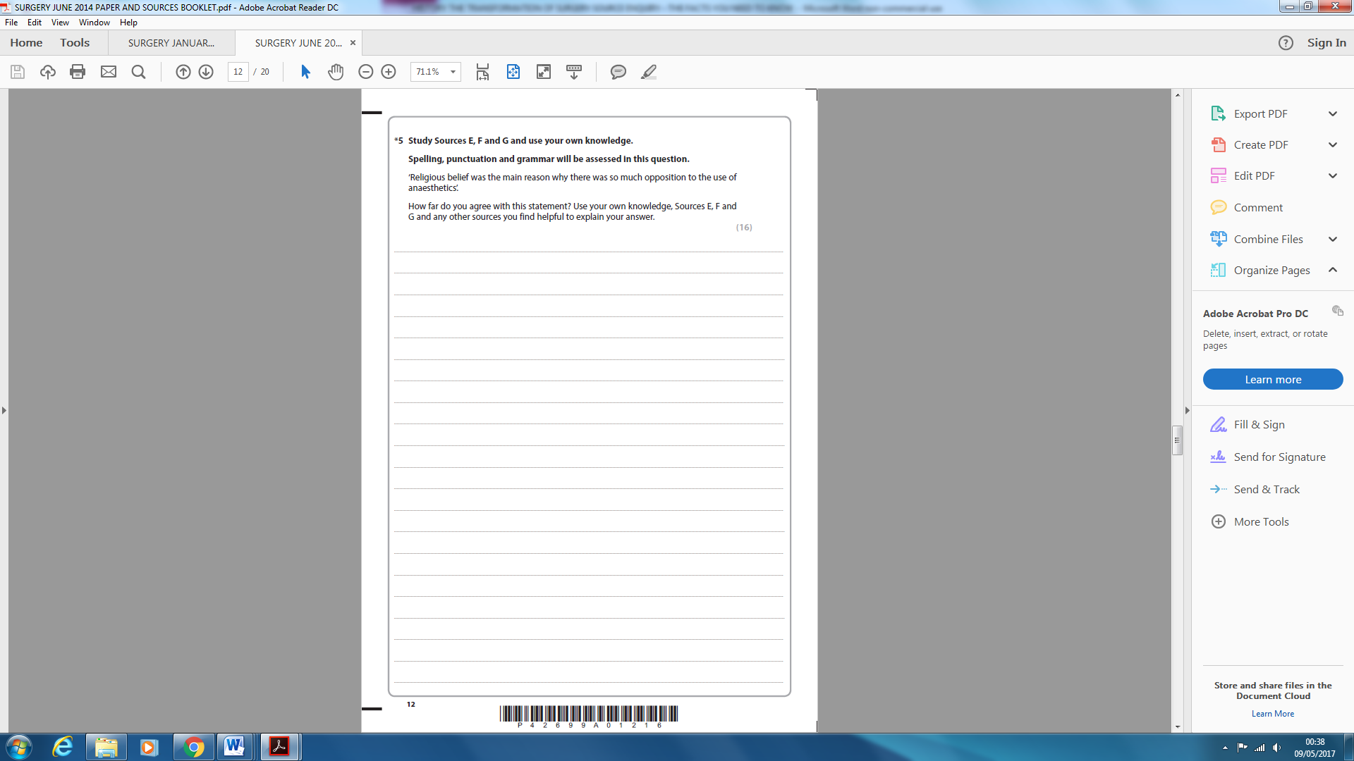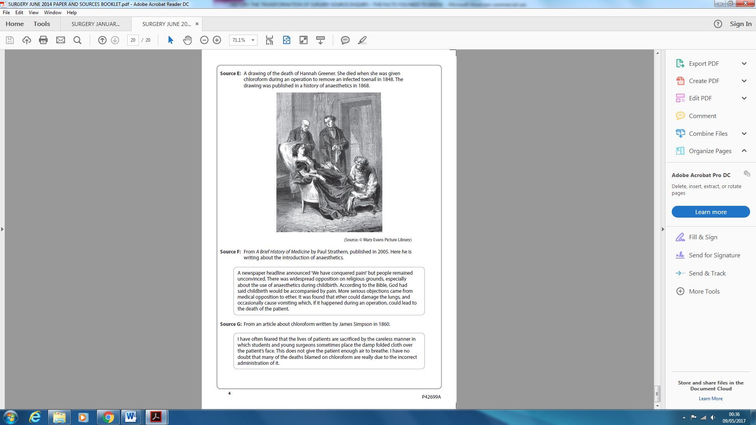

*Let us re-introduce ourselves to the **hypothesis** question – remember a hypothesis is an idea or explanation which is based on knowledge of facts (sort of educated guess) which is not perhaps fully proven but definitely leads to a discussion – it is usually in the form of a statement.

The hypothesis is ‘religious belief was the main reason why there was so much opposition to the use of anaesthetics’

*It is very important that you distinguish between the two different types of hypothesis question – the first asks how far do the **sources** agree with the hypothesis and the second is how far do **you** agree with the hypothesis.

*In this example the question asks how far do **you** agree with the hypothesis and not how far the **sources** agree with the hypothesis.

Think of a balance



Challenging sources which disagree with hypothesis

Supporting sources which agree with hypothesis

*First read sources and compare them with the hypothesis – this is not how far the sources agree remember but how far you agree with the hypothesis. What do you think? Do they totally agree/totally disagree, or do they perhaps do a bit of both? It happens quits a lot that they contain elements of both. Usually though even if they are fairly balanced, they will be weighted more one way. It would be a good idea to annotate or underline important parts because you need evidence from the sources in your answer. Embedded quotes are useful.

Annotations for source E might include that it shows death of a patient which would have a big impact on feelings about anaesthetics. It does not mention religion and so does not support the hypothesis.

Annotations for source F might include that it mentions religion as an opposing factor, especially during childbirth, quoting the Bible and God that it should be accompanied by pain. However, also introduces the fact that ‘more serious objections’ are medical objections again concerned with death like source E. Even though it mentions religion it does not support the hypothesis.

Annotations for source G might include that it again mentions death of patients as a result of anaesthetics, and goes someway to explain they may be due to careless administration causing suffocation. It does not mention religion and so does not support the hypothesis.

*An important mistake that examiners constantly comment on is that students fail to cross reference sources against each other as they proceed through their answer. They do not like seeing an essay format where source A is compared to hypothesis first, then source C and then source D and so on. They want to see the sources compared to each other – they see this as a major mistake.

*So far then we have read sources and underlined important evidence and annotated our thoughts, which will be used to cross reference the sources and contribute towards the bulk of our answer – the middle bit of the essay.

The introduction will be a short paragraph which identifies **key issues** and **key argument** with a little evidence.

1. **Introduction in answer** (mixed in with own knowledge as seems appropriate so own knowledge does not appear later)

‘I am aware that Christians at the time thought that pain, especially of childbirth was God’s plan and was a blessing. I would also consider that medical developments were always met with suspicion as doctors did not like changing old methods. When Hannah Greener died it had a big impact and scared doctors. Anaesthetics also encouraged more complex surgery and initially led to a higher death rate. Patients dying would obviously make doctors oppose these new methods.’

Now let us use our source annotations to form the next paragraph as we cross reference them.

1. **Cross-referencing in answer**

‘Source F says outright that pain relief is going against God’s will, especially childbirth but also introduces the fact that ‘more serious objections’ are medical objections concerned with death. This is the only source to mention religion as an opposing factor but concludes medical opposition is a stronger opposing factor. Sources E and G support F in the respect of the problems of death, as they are mainly concerned with the deaths that can result from anaesthetics, and source G goes someway to explain how these deaths may not be a result of chloroform itself but careless administration causing suffocation. This would be a difficult thing for doctors to accept.’

*Now we must cover something new – the issue of reliability of sources. How reliable are these sources as accurate sources of information? It is important isn’t it as we need to know we are basing our conclusions on accurate information?

**Evaluation of sources for reliability using NOP (Nature, Origin and Purpose)**

1. **Nature**

This is easy part

**Is it a speech, photo, painting, cartoon, diary extract, an article in a scientific journal, extract from a textbook etc.?**

1. **Origin**

This is most detailed part

**Who** produced it and are their views worth knowing – are they an expert?

**Who** is it aimed at?

**When** was it produced? Is it primary or secondary?

* Primary is produced at the time and/or by someone who was there – often a personal view of someone wrapped up in the moment – a snapshot who may not see the bigger picture
* Secondary is a source after the event or by someone who was not there – again often a personal view

**Opinionated or biased or balanced/factual/informative**

**Modest or exaggerating?**

**Limited view or broad view?**

**A note about primary sources**

The thing about paintings, drawings and cartoons is that they capture the spirit of the time and the feelings of people at that time

The thing about photos is that they capture moments in history in vivid detail but can be posed and are controlled by photographer – we do not see outside of the photograph do we?

What about newspapers? They can provide a record of events but they may be biased and contain propaganda.

What about interviews? They can take place years later for biographies with faded memory, and with benefit of hindsight the interviewee may alter the past.

**A note about secondary sources**

Can be clearer because hindsight puts things into context.

Often a narrower view concentrating on a particular enquiry and well referenced e.g. textbook

1. **Purpose**

For example: adverts are designed to make you buy the idea or product, speeches are usually to support the topic, was it propaganda? , was it designed for public or private knowledge? , textbooks are usually to educate and are well referenced.

Compare all of above NOP with your own knowledge and do they match up?

1. **Reliability in answer**

‘Source F is an extract from a modern textbook on history of medicine. The purpose is to inform and educate and the author would have done a lot of research preparing the book using primary sources as reference. I would regard it as reliable. The reliability of E and G obviously need to be taken into account as the value of them in the counter argument relies to some extent on this. Source G, I would regard as a highly reliable source, written by James Simpson himself – the discoverer of chloroform. Source E is an awkward one to judge as even though it was drawn in the era of chloroform, it may be open to representation by the artist – nonetheless the subject is death and Hannah Greener did die from chloroform – so in this respect it is truthful.’

Now address the question.

1. **Summary in answer** (with bit of own knowledge again)

‘My judgement is that the sources are not majorly different in reliability, and source F even though it is the only source to mansion religion as an opposing factor, clearly states that medical opposition is a stronger opposing factor and that is what I also believe. I therefore disagree with the statement and believe medical opposition was the main opposing factor. Interestingly, doctors who opposed anaesthetics would themselves have articles published in respected journals saying that pain was part of God’s plan – because they hoped objecting on religious grounds would have a big impact and discourage people – as they felt suspicious of it for other reasons that ordinary people might not understand.

Let’s look at a January 2012 question, where I have not been able to locate sources booklet online, but I think this is source B to match the question.

**Study Source B.**

What impression has the artist tried to give of Simpson’s experiment? Explain your

answer, using Source B.

[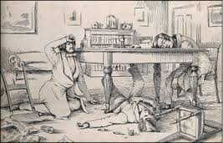](https://www.google.co.uk/imgres?imgurl=http://www.openbookpublishers.com/htmlreader/978-1-78374-117-5/image/15.2.jpg&imgrefurl=http://www.openbookpublishers.com/htmlreader/978-1-78374-117-5/Ch-15.xhtml&docid=rK8hVIG6io6HzM&tbnid=veY-jtFJ3fmO2M:&vet=10ahUKEwiWwMbwyuHTAhVHB8AKHT1EBfYQMwgqKAAwAA..i&w=334&h=214&bih=985&biw=1920&q=simpsons%20experiment%20chloroform&ved=0ahUKEwiWwMbwyuHTAhVHB8AKHT1EBfYQMwgqKAAwAA&iact=mrc&uact=8)[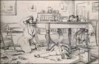](http://www.google.co.uk/url?sa=i&rct=j&q=&esrc=s&source=images&cd=&cad=rja&uact=8&ved=0ahUKEwiWwMbwyuHTAhVHB8AKHT1EBfYQjRwIBw&url=http://www.openbookpublishers.com/htmlreader/978-1-78374-117-5/Ch-15.xhtml&psig=AFQjCNF_yYiN4W5IN7Ct931OX4W7pBVl8Q&ust=1494377162194717)

(Note – this question is worth more marks than a simple comprehension question, and expects some of your own knowledge of the topic. These questions that ask ‘what impression is artist giving’ or ‘what is the purpose of this representation’ are looking for the MESSAGE and the PURPOSE of that message.)

1. The PURPOSE of this drawing is to show the effects of chloroform which have knocked the three men out and is made to seem risky looking at state of room and men

1. This MESSAGE is conveyed by –

The experiment ended in disorder with things scattered all over the floor and only one man partly conscious

The friends seem unaware of what happened so must make people unaware of pain

Shows experiment as risky and possibly dangerous because all three have ended up unconscious

Just a little thing – examiners say that sometimes students get confused with origins of extracts as they look at the date of publication but this may not be the date of the original piece – it may have been a primary source at the time but published years later.

Also remember speeches can be about people and not by that person.

**Finally ③DEALING WITH BLOOD LOSS**

* **By end of 1800’s blood loss was only major barrier left to successful surgery**
* Blood loss had always been a major problem in surgery as heavy bleeding is caused when blood vessels are cut
* Bleeding makes it difficult for a surgeon to see what he is doing, but also if patient loses too much blood the heart is affected and the patient dies
* Surgeons had to be careful patient did not lose too much blood during operations because they could not replace it
* Early attempts at transfusion sometimes worked and sometimes resulted in blood clotting and death and no one knew why
* Once anaesthetics and antiseptics made it possible to perform deeper operations there was a renewed drive to find a way of dealing with blood loss by dealing with the two main problems of blood loss - **by controlling blood loss and also by replacing lost blood with transfusions**
* The usual way of sealing blood vessels to **control loss** was by placing a hot iron onto wound or pouring hot oil over it – called cautery- very painful
* Later (16th century) Pare developed metal clips to clamp arteries during operations to control loss
* He also tried tying them using silk thread but this was not always successful – cautery remained main method of reducing blood loss
* This was before **Pasteur’s Germ Theory of 1861** and there was no understanding of a surgeon’s dirty hands inside a wound causing infection so high death rate with surgery
* In **1900** **KARL LANDSTEINER** discovered **BLOOD GROUPS** and the problem of incompatibility of blood groups (where certain blood groups will clot if mixed) was solved during transfusion
* We are now eliminating chance of death when carrying out transfusions as we know which blood group to use
* But donor needed to be present to provide blood wherever it was needed for direct transfusion, as blood could **not be stored and this was not practical on the battlefield,** so his work did not have big immediate effect on surgery
* **\*\*During First World War (1914 – 1918) many soldiers were dying through blood loss on a scale never seen before (when the wound may not be fatal itself) and the search to solve the problem became important** WW1 WAS DRIVING FORCE**
* In **1915 RICHARD LEWISOHN** found adding **SODIUM CITRATE** stopped clotting of stored blood but the blood did **not have a long life,** but still **saved thousands** of wounded soldiers in World War 1as it could be stored for a few days
* **RICHARD WELL** found that separation of blood into the liquid and blood cells meant the blood cells could be **stored in bottles in ice**, and adding warm saline made useable blood – made transfusions possible for thousands of wounded soldiers on the front line which took longer to reach by transport
* Finally it was discovered that adding citrate glucose allowed blood to be stored longer
* When an attack was planned donations from public could be stored to treat wounded

* **The first blood depot was established in 1917 for the Battle of Cambrai using blood group O which is a universal donor**
* Once technology was created to store blood the issue of blood loss was solved
* Remember this had been done by First World War but it was early days
* Remember the issues with blood transfusions was not always about lack of knowledge about how to transfuse blood but just because the supply was the problem – no one had seen blood loss on this scale before – supply could not keep up with demand
* There were problems with supply also because transport was an issue trying to get the blood and other medical supplies to the front line where it was needed
* Overcoming blood loss was an important stage in the development of surgery – although it depended on increased scientific knowledge as shown –** **it was definitely accelerated by the casualties of war as this put new emphasis on the search for answers\*\***
* **War has an effect – surgeons do more operations and are prepared to work harder**
* **Surgeons unite to share ideas to help their soldiers rather than looking for personal glory of coming up with new ideas themselves**
* **Industry devoted itself to developing what is needed for the war effort in this case developing new surgical equipment**

**Impact of first world war on development of surgery**

* Surgeons had to treat lots of casualties in temporary operating theatres and conditions were horrendous
* Surgeons had to improvise and this led to developments
* Surgeons had to deal with a wide variety of wounds which gave them a very broad training
* Surgeons gained a lot of experience very quickly
* New weapons meant new type of wound
* **Deep wounds from shrapnel led to surgeons developing saline to wash wounds to fight infection**
* First attempts at brain surgery started
* Plastic surgery was developed to tackle disfiguring injuries
* **Remember a general problem of war is transport i.e. have to get supplies – including medical and including blood to front line**

**So what had to happen because of WW1?**

Problems were created and changes had to be made to deal with them. These huge problems drove surgeons to find answers – people were dying – horrors of war – something had to be done. War had the effect of pushing forwards development as there was a lot of practice for surgeons seeing injuries they had probably never seen before. They had to come up with answers and try different techniques – it was a huge learning environment for them But also they were so dependent on supplies such as chloroform and antiseptics and blood which were in short supply, because of transport problems. So technology may have discovered answers but not much good if cannot get hold of these answers because of transport and supply problems.

*Think of your mental timeline and add to it now so that you do not stray outside dates stated in questions - ether 1846, then chloroform in 1847 and the period of 1846 -1870 known as Black Period of surgery – then enter Lister and his carbolic spray around 1867 after reading Pasteur’s Germ Theory in 1861 (took 6 years to apply it to surgery) – then death rates improved dramatically. Blood group discovery in 1900 but not much use on battlefield, but luckily by start of WW1 storage of blood was possible, firstly by addition of sodium citrate and later on by separation of blood and addition of citrate glucose. Blood could be collected from public and stored in depots.

WW1 is at the **end of your time period** for this enquiry which is helpful as it shows developments you are reading about **have all happened** – even if only just - i.e. even if it is early days for those developments such as blood being stored for transfusion when needed after blood loss, but you know that you are not talking about stuff that has not happened yet

Examiners say that a general problem with this source paper is that sometimes students talk about developments that have not happened yet – with WW1 know you are okay.

**BLOOD LOSS IMPORTANT REVISION STUFF**

* Remember anaesthesia and antiseptics had been addressed so blood loss was only major barrier left to successful surgery
* Surgeons had to be careful patient did not lose too much blood because could not replace it
* In 1900 Karl Landsteiner discovered blood groups which made person to person blood transfusions possible – **these were not possible in wartime on the battlefield**
* In 1907 Reuben Ottenberg performed first successful transfusion using blood typing
* **Once technology was created to store blood issue of blood loss had been solved**
* Look at your notes again to see progression from addition of sodium citrate to separating blood cells and finally citrate glucose solution gradually allowing blood to be stored for longer.
* **So during the first world war, successful storage and transportation of blood became urgent concern, this meant better funding for research from government**
* **Scientific development developed these methods but**
* **But without the war the methods might have taken longer to develop**

**Source A - Blood transfusion kits being packed at the British Army Supply Depot (photograph)**

**Source B – Taken from ‘A Method of Citrated Blood Transfusion’, by O H Robertson, published in the British Medical Journal in 1918. Robertson was the first doctor to use sodium-citrate-treated blood on soldiers during the First World War.** ‘This method (of blood transfusion) was used under rush conditions. Forty four transfusions were given to 38 patients. The patients transfused were cases of haemorrhage and shock –chiefly the former…the immediate effect of the citrated blood was the same as that seen after the transfusion of blood by other methods in common use.

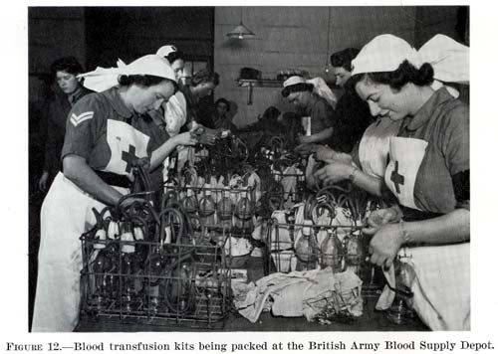

How **RELIABLE** are sources A and B as evidence of the changes in blood transfusions by 1918? Explain your answer, using sources A and B and your knowledge. **NOP – nature – origin - purpose is for reliability PLUS YOUR KNOWLEDGE TO DETERMINE IF FACTS ARE ACCURATE, AND YOU MUST ADDRESS THE QUESTION WHICH IS NOT JUST ASKING FOR RELIABILITY BUT ALSO IF THEY ARE GOOD AS EVIDENCE OF CHANGES - MUST BE ANSWERED BY USING CONTENT AS THIS IS THE EVIDENCE NOT JUST YOUR KNOWLEDGE**  The sources are quite reliable when considering how blood transfusions had changed by 1918. Source A seems reliable because it is a picture taken at the time and shows that blood was able to be stored and transported (DESCRIBES THE CHANGE - ADDRESSING QUESTION USING CONTENT) which was a new development in blood transfusion. Source B is also reliable as it is from a medical journal written by a doctor who was using the new methods based on his own experience, which would have been checked before publishing. This was also a significant development (DESCRIBES ADVANCEMENT SO ADDRESSING QUESTION USING CONTENT) as it allowed safe storage of blood, as person to person transfusion was impractical in war. From my own knowledge I know that terrible shrapnel wounds hurried up research into blood transfusion and storage because of blood loss on scale never seen before, which required a huge amount of blood causing banks to be set up. The sources agree with my knowledge and their accuracy increases their reliability. bbbbbbbbbbbbbbbbbbbbbbbbbbbbbbbbb

………………

…………………………………………………………………………………………………………………………………………………………………………………….